**Lab: 11**

**Serial Communication**



**Spring-22**

**Microprocessor Based System Design Lab**

Submitted by: **Ashfaq Ahmad**

Registration No: **19PWCSE1795**

Class Section: **B**

“On my honor, as a student of the University of Engineering and Technology, I have neither given nor received unauthorized assistance on this academic work.”

Student Signature: ______________

Submitted to:

**Dr. Abeer Irfan**

August 2, 2022

Department of Computer Systems Engineering

University of Engineering and Technology, Peshawar

**Code:**

**uC1:**

|  |
| --- |
| #include <reg51.h>  #include <stdio.h>  #define input P1;  *double*DG_signal;  // ADC pins  sbit Read = P3 ^ 3;  // rd pin will use for reading  sbit Write = P3 ^ 4; // wr pin will use for writing  sbit INTR = P3 ^ 2;  // intr is used for interrupt  *void*Analogue_to_digital()  {      Read = 1;  // high to low to read from adc      Write = 0; // low to high to write on adc      // delay(1);      Write = 1;      while (INTR == 1)          ; // low active interrupt      Read = 0;  }  *void* main(*void*)  {      TMOD = 0x20; // Auto Reload Mode of Timer1      TH1 = 0xFD;      SCON = 0x50;      PCON = 0x00;      TR1 = 1; // Set TImer1      while (1)      {          Analogue_to_digital();          SBUF = input; // register for serial communication          while (TI == 0)              ; /// when the transmission done the T1==0          TI = 0;      }  } |

**uC2:**

|  |
| --- |
| #include <reg51.h>  #include <stdio.h>  *unsignedint* y;  *void* main(*void*)  {      TMOD = 0x20;      TH1 = 0xFD; // bps 9600      SCON = 0x50;      PCON = 0x00;      TR1 = 1;      while (1)      {          while (RI == 0)              ; // Stays here until the Data is received          RI = 0;          P1 = SBUF; // Throws the output data to P1      }  } |

**Schematic:**

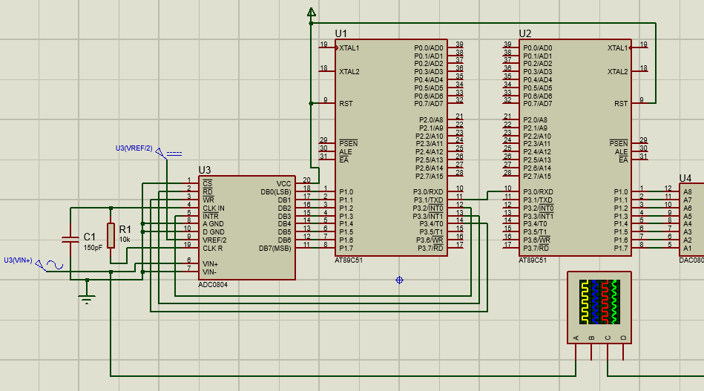

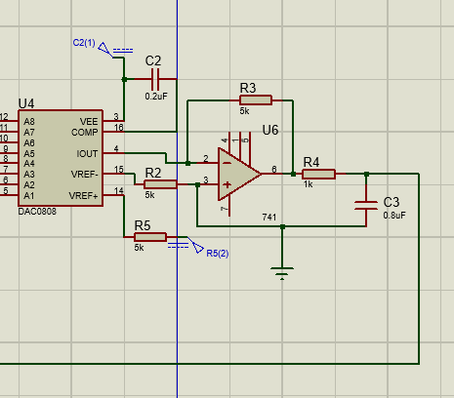

**Output:**

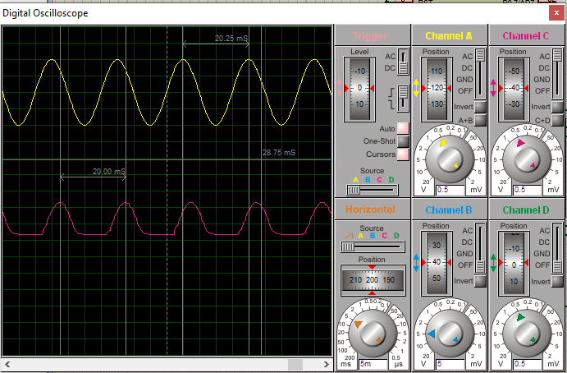

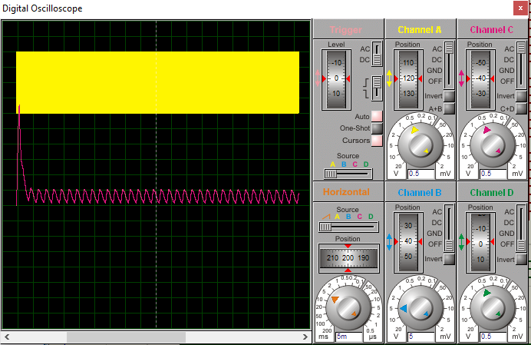

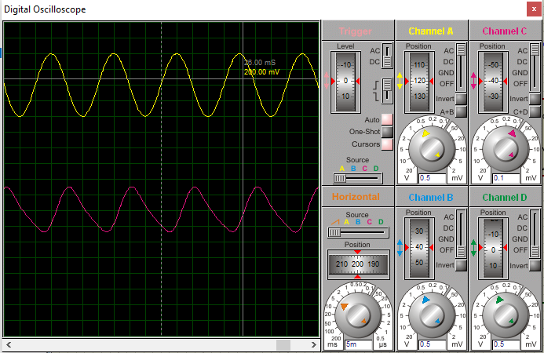

**Ended**